Oceania-INDO-Biak Island-Korwar Figure

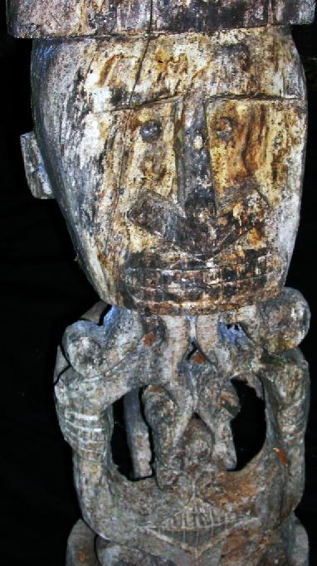 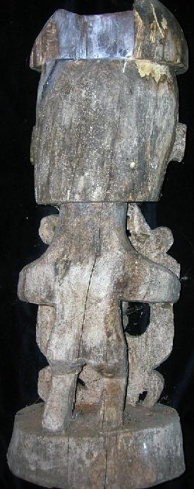 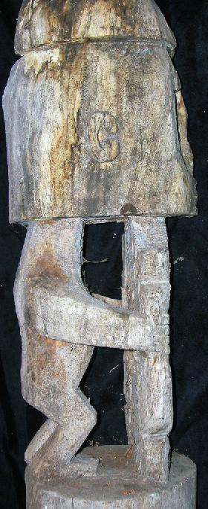\

**Korwar ancestor figure 26 in. tall, sculpted in wood and showing evident patina of age. This korwar comes from a large ethnographic collection acquired by the Bouck Estate, New York City, in 2014. This figure was excavated from Biak Cave on Biak island prior to 1942 when the Japanese invaded the island and desecrated the interior. The cave was finally burned with gasoline by Allied Forces in 1944. Because this figure shows great patina it must date from the late 19th or early 20th century as a ceremonial object. The last skillful korwar carvers in Biak kept a large collection of korwar and other artifacts until Christian missionaries converted the Papuan inhabitants and destroyed traditional figures such as this.**

**This figure was designed for actual ceremonial use and was not produced as an art object for collectors: hence it has anthropological and ethnological value unlike art imitations.**

**The Melanesian Austronesian -speaking peoples of the coasts and islands of Cenderawasih Bay in northwest New Guinea formerly created korwar figures that portrayed recently deceased ancestors in which the skull of the deceased was placed over the head of the figure so that the korwar's eyes could peer out through the skull's orbits. Korwar images served as supernatural intermediaries, allowing the living to communicate with the dead, who remained actively involved in family and community affairs. When a family member died, relatives summoned a carver, typically a religious specialist, who created a korwar and enticed the spirit of the deceased to enter it.**

**Korwar imagery was highly conventionalized, depicting the ancestor in a seated or standing position with the robust head to hold the skull and an arrow-shaped nose denoting their Melanesian ethnicity that are the hallmarks of Cenderawasih carving. Although the sex of the figures is often difficult to determine, it was dependent on the gender of the deceased. Kept by the family, korwar were consulted during crises and prior to important undertakings, such as trading voyages, warfare, or fishing. When a korwar's advice proved sound, it was shown great deference. However, if the korwar's advice proved faulty, those who had consulted the image vented anger on the figure physically by hurling it against the walls of a house or even destroying it.**

Biak cave, on the island of Biak, Indonesia.Location Lat 1° 0' 0S Long 136° 0' 0E Biak Island is located to the north of the New Guinea mainland. To the south is Geelvink Bay. 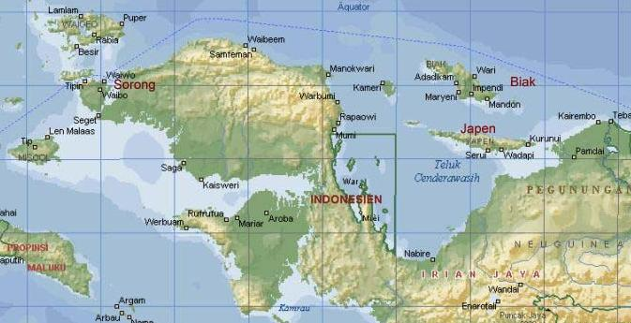

The unspoiled island of Biak is located in the Cendrawasih Bay of Papua (Irian Jaja), west of Papua new Guinea. Biak island itself is the biggest island in the Biak-Numfor regency with 1.898 square km area. The entire area of the regency is 3.130 square km which has a total 67 islands.

Each island is surrounded by a pristine white sandy beach with the breath-taking beauty of colourful shallow coral reefs and magnificent deeper coral gardens. The water is usually calm with visibility often excided 50m (150ft. Water temperature remains about 30°C all year round.

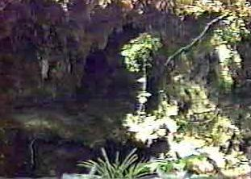

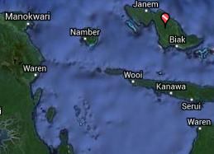

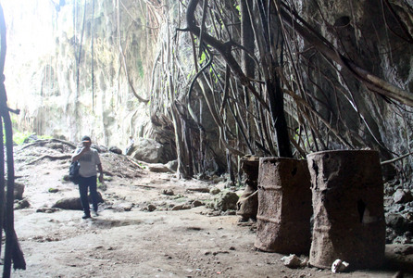

Korwars are carved wooden reliquaries that date to the late nineteenth or early twentieth century from Biak Island in Cenderawasih Bay at the western end of the northern Province of West Papua New Guinea, Indonesia, (1oS, 136oE).

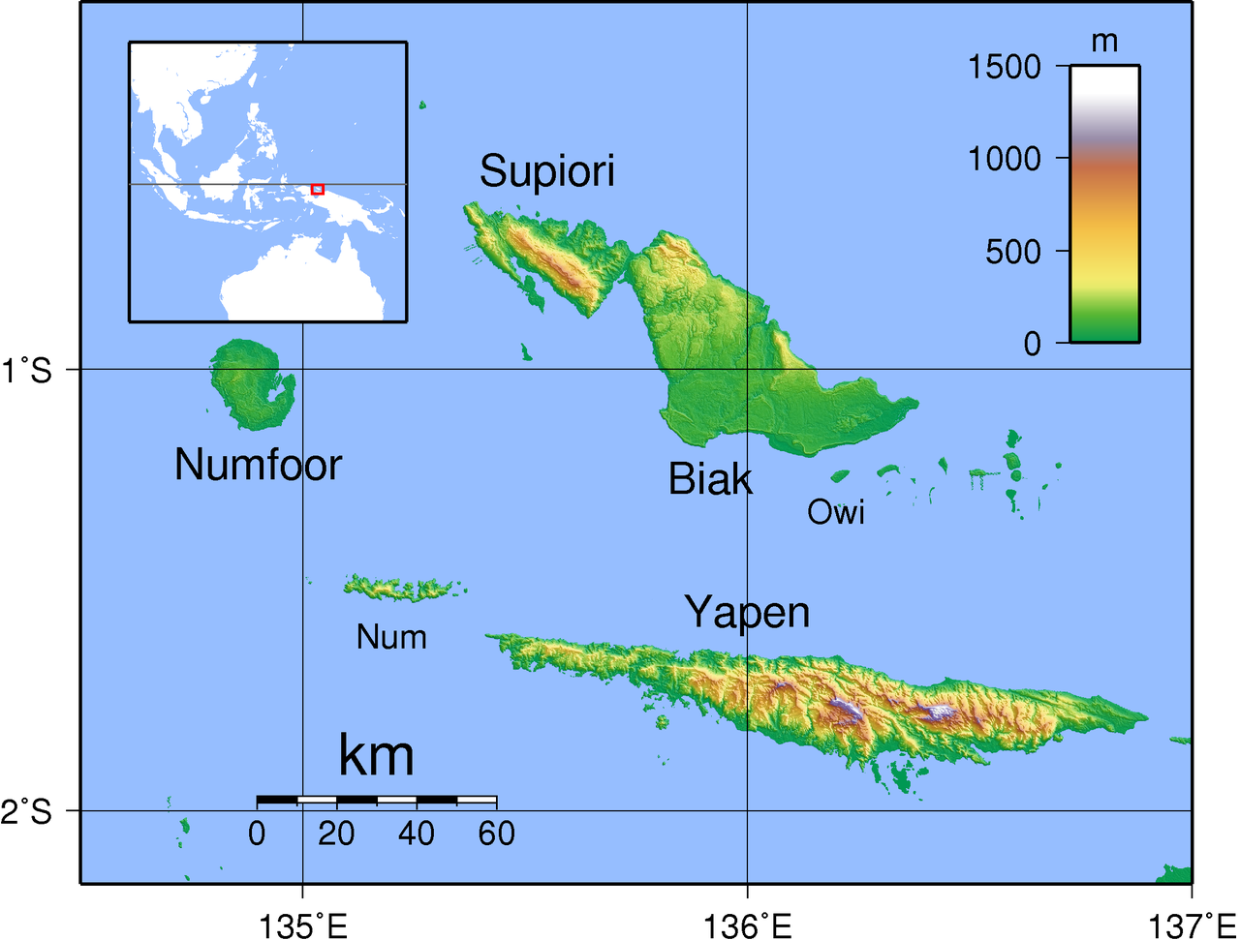

Topographical map of Biak in the Schouten Islands, Cenderawasih Bay, Indonesia. Created [by Sadalmelik](https://commons.wikimedia.org/wiki/User:Sadalmelik) in 2007 with GMT from publicly released SRTM data.

Korwars are carved wooden reliquaries that function as receptacles for spirits of deceased ancestors. They serve as supernatural intermediaries the permit communication with the deceased, who can remain actively involved in family and community affairs, if the shamanic sculptor of the korwar can entice the spirit of the deceased to enter it. Since death in Biak is regarded as an imbalance that has to be mediated, the deceased is invoked as a spiritual medium that should be venerated.

Each korwar is carved to represent the spirit-face of a specific deceased ancestor. Sometimes the actual skull of the ancestor is placed atop of the visage of the *korwar*. The *korwar’s* carved head, with its exaggerated proportions with respect to the rest of the sculpture, reinforces its sanctity as being the receptacle of the ancestral spirit.

Below the carved head is an intricately carved curvilinear design that represents a snake. Since snakes shed their skin they are regarded by the Biaks as symbols of rebirth. These snake sculptures are also carved on the prows of spirit-canoes that house a coffin and are placed in mortuary contexts such as caves. On some *korwars* there is a representation of teeth like dentles within the snake design and for this reason it is probable that the amethystine python ([*Morelia amethystina*](https://en.wikipedia.org/wiki/Morelia_amethystina)) is intended with its teeth-like design on the side of its jaw.

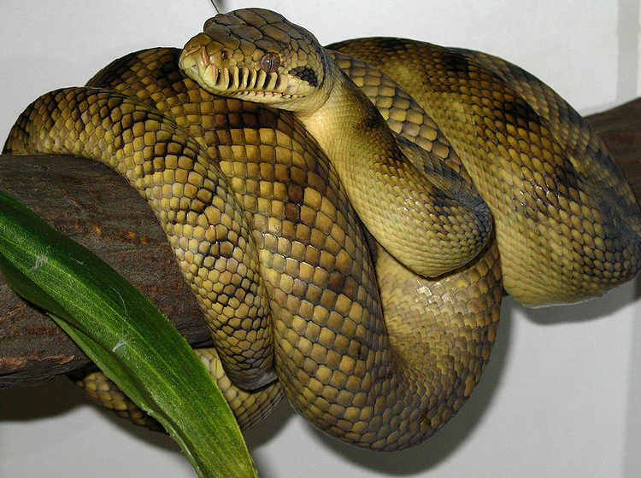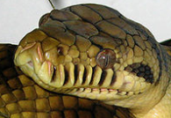

# [***Morelia amethystina***](https://en.wikipedia.org/wiki/Morelia_amethystina)photographed in 2007 by Mike Wagner.

The *korwar* has three functions. Firstly, it provides a protective role for homes, childbirths, weddings, and funerals. In the last instance, Korwars serve as guardians of the coffin of the deceased that is placed in mortuary canoes in which each spirit voyages on its journey to the afterworld. These canoes are often placed in mortuary caves that are sometimes embellished with pictographs of these spirit canoes. Secondly, the *korwar* may also be dedicated as a village emblem when a leader is considered to be exemplary by local people. Thirdly, *korwars* may act as oracles when a village shaman invokes it to advise about specific actions that should be undertaken in village matters, such as resolving disputes or waging peace or war.

Sold by [primitifstuff](http://myworld.ebay.com/primitifstuff) ( [1804](http://feedback.ebay.com/ws/eBayISAPI.dll?ViewFeedback&userid=primitifstuff) )

### Delivery package 1 of 1

Estimated delivery Wednesday, Oct 14, 2015 - Saturday, Oct 17, 2015

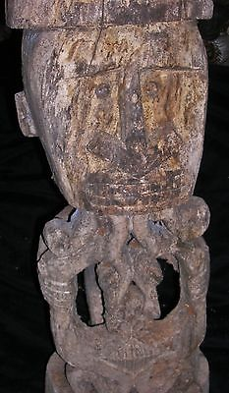

#### [BIAK CAVE FIGURE SKULL HOLE 26"](http://www.ebay.com/itm/221902128113)

|  |  |
| --- | --- |
| Item price | $89.99 |
| Quantity | 1 |
| Item number | 221902128113 |
| Shipping service | USPS Priority Mail |